Introducing a zero standing charge energy price cap variant

Overview
We are seeking views on a new zero standing charge option within the energy price cap which will give household bill payers more choice in the energy market.

Who should respond
We would like to hear from energy suppliers and consumer groups. We would also like to hear from industry groups and network companies.

Background
In August 2024, we asked for feedback on options to reduce household standing charges. We found that many consumers wanted us to reduce, significantly change or remove standing charges entirely.
Many of these consumers shared that they would prefer to pay for their energy based only on use (unit rates) rather than also paying a standing charge. In general, they wanted more choice and control over how they pay for their energy costs.
We are looking to create a zero standing charge option that allows consumers to choose how they contribute to these costs. In our consultation, we explain the different ways this could work and other details, such as how consumers might get onto the tariff.

Why your views matter
Your feedback will help us understand how this new variant could work, if the proposed tariff options are suitable or whether alternative options should be considered. If implemented, consumers could choose to opt into it from next winter.

Contents
We’d like you to answer all the questions in this consultation that are relevant to you, or where you have an interest. If you do not feel comfortable answering any of the questions, you can leave them blank.
After you have read each chapter, you can select the ‘Save and come back later’ option found at the bottom of each page.
If you start responding to the consultation and want to return to it later, select 'Save and come back later' to save your answers. You need to answer the questions on the 'About you' page before submitting your response.
Your responses will not be included as part of the consultation if you do not submit them before the closing date.

Other ways to give us your views
You can upload a supporting document at the end of the consultation which will get published alongside the answers you have submitted.
If you would prefer to give us your views in another way, you can send us your answers to the consultation questions by emailing them to standingcharges@ofgem.gov.uk.

Chapter 1: introduction
Outlines what we are consulting on and the background, what we want your feedback on and next steps.

Chapter 2: case for change
Sets out our reasoning behind introducing a new variant based on previous feedback.

Chapter 3: Tariff structures and impacts
Summarises the 3 tariff structures that could be used and our design methodology and modelling.

Chapters 4 to 6: single rate tariff, falling block tariff and rising block tariff
Compares consumption scenarios and the annual cost of energy on the zero standing charge price cap variant for each tariff structure.

Chapter 7: risk and uncertainty
Summarises the main risks of introducing a new variant, particularly under recovery, and potential ways to overcome these.

Chapter 8: implementation approach
Explains how the variant could be implemented and the customer journey.

Executive summary
Standing charges play an important role in the retail energy market. They ensure that all consumers contribute towards network build, upgrade and maintenance costs that are necessary to keep connected and to support progress towards net zero, contribute to social policies and allow suppliers to recover the fixed operational costs of serving each consumer.
We have had significant engagement on standing charges, with tens of thousands of individual consumers contacting us, either independently or as part of email campaigns. Overwhelmingly, those responses called for us to take action to reduce standing charges.
Because standing charges pay for efficient costs that are part of our energy system, the only way to reduce standing charges is to add the costs to unit rates. And because all households have different needs and wants, there is not a balance between standing charges and unit rates that would be better for everyone. We set out in December 2024 that if we make a change for everyone, some, including vulnerable households, could lose out.
Direct feedback from consumers has highlighted that some people would prefer to pay for their energy solely based on use (unit rates) rather than also pay a standing charge. Households will have many different reasons for this preference, and these reasons could be financial or otherwise.
In line with this feedback, we want to try to bring about more choice in the market, so consumers have different options for how they contribute to these costs. We called on suppliers to voluntarily make more choices available in the fixed tariff market. While there are signs of progress, we are not seeing the pace of change needed.
We are therefore seeking views on the introduction of an option within the price cap that does not have a standing charge, as a way of addressing the market’s failure to offer a wider variety of products where consumers have expressed a strong demand. This would be alongside the existing price cap options that include a standing charge. If implemented, this would be available from next winter for consumers to opt in to, including with their existing supplier.
We acknowledge the widespread sentiment in our consultations on the overlap between standing charges, affordability and debt. We are not developing this option with the aim of creating financial savings for particular groups of consumers but have other work ongoing, for example introducing a debt relief scheme to address issues regarding energy affordability.
Our consultation looks at different ways a zero standing charge tariff could work. We outline options with a single unit rate, as well as block tariff options where the unit rates go up or down once you've consumed a certain amount. Each of these tariff types have different effects on consumers and the market, and we want to hear views on which would best achieve the aims of this policy.
Whether a household would be financially better off on a tariff without a standing charge depends on a lot of things, especially household energy use, and which potential tariff structure we proceed with (single rate, falling block, or rising block). Financially, it is possible a small 1 bedroom flat with good energy efficiency could be better off on one of these tariffs, while an inefficient 3 or 4 bedroom household would probably pay more overall. The extent of these differences will depend on the further detailed design of the tariff.
Our primary aim though is to create more choice for how these costs are paid. We think there are circumstances where households would get personal benefit from a zero standing charge tariff, even if they may not be financially better off over a year. One example is prepayment consumers, who are more likely to manage their household budgets on a week to week or month to month basis. We have heard that many households would appreciate being able to budget only for energy use during a particular week or month. For example, in the summer when gas use may be low or zero, a prepayment customer on a zero standing charge tariff would not incur costs over periods of non-use. Instead, the cost of the standing charge would be paid when more energy is used in the winter months.
Another example is for a household that may spend an extended period of time away from home, for example if visiting family abroad, or for an extended hospital stay. Some customers would prefer to not return to an energy bill made up of only standing charges. Under the zero standing charge variant, these customers would instead pay for the standing charge costs through their unit rates over the rest of the year.
Creating a new price cap variant would be responding to clear demand we’ve heard for short term change on standing charges. Through this consultation we are seeking feedback on how this variant could work. If we proceed to implementation, we would keep the variant under review to ensure it continues to be relevant as further market change comes about as we continue to move to a new and flexible net zero energy system.

Introduction
This consultation looks at how we could introduce a price cap variant without a standing charge.
Consumers have told us that they strongly support having more choice and control over how they pay for the costs that make up the standing charge. This variant would give consumers this option as part of managing their bills. If we make these changes it could introduce risks within the energy market, especially around contribution towards fixed costs.
As a regulator we also need to make sure that suppliers are still able to fund their activities while protecting existing and future customers. We want to hear your views about:
- our case for change
- different ways that the proposed zero standing charge variant (a variant of the existing energy price cap that covers tariffs with zero standing charges) could be structured to benefit consumers and minimise market risks
- the implementation considerations, such as how consumers join and leave the variant, and how eligibility could be targeted
- our assessment of the impacts and trade-offs involved in the options and implementation considerations outlined

Background
Standing charges play a legitimate role in the retail energy market. They recover the fixed costs of the system, by which we mean costs that do not vary by energy use.
This includes suppliers’ fixed operational costs of serving each consumer, for example running energy supplier call centres, the cost of network upgrades and maintenance necessary to keep all consumers connected, and fund the technologies to progress towards net zero targets. It also includes the cost of providing Warm Home Discount payments to eligible customers.
We launched our review of standing charges in our call for input in November 2023. We wanted to get views on what consumers thought about the way that standing charges are added to electricity and gas bills.
We opened the conversation with the understanding that removing standing charges would not take away the need for suppliers to recover their relevant costs.
Following significant engagement from consumers and stakeholders, we have looked at a number of policy areas in efforts to address consumers’ desire for change while retaining regard for suppliers’ financial viability (a supplier’s ability to operate effectively and deliver against financed activities).
Overwhelmingly, consumer responses have called for us to take action to reduce standing charges. Many domestic consumers voiced a clear desire for standing charges to be reformed significantly or abolished entirely. Ultimately, consumers shared their frustration over the daily standing charge, particularly those with low usage where the standing charge cost is a significant portion of their energy bill.
Our Standing charges: domestic retail options paper, published in August 2024, set out specific trade-offs on taking action on standing charges in the short term. In December 2024, we published the summary of responses to this options paper.
Despite Ofgem calling on suppliers to offer products that meet this expressed need available in the competitive market, we have not seen enough response. This options paper had another significant response from members of the public. We provided updates in 3 areas based on the responses received:
- we would not shift costs from standing charges to unit rates for all customers under the energy price cap given the potential harm to some vulnerable customers (for full details see our energy price cap operating cost and debt allowances consultation)
- we are opening a new project to review the recovery of system wide energy costs, such as electricity and gas network costs
- we will consult on a zero standing charge variant to the existing price cap (this consultation)

Next steps
The consultation will be open to responses until 20 March 2025. Following the consultation period, we will review all responses, which help inform our next steps.
If we proceed with the proposed new price cap variant, we will then publish a statutory consultation which would outline precise details of the new policy and any licence changes that would be required. If implemented, we expect it would be available from next winter.
Your feedback will help us in considering whether and how to introduce a zero standing charge price cap variant.

Case for change
In our update published in December 2024 we set out our decision to not change the standing charge for all consumers on the energy price cap. This is due to the potential to introduce harm for some vulnerable groups, for example those with high energy usage as a result of medical needs or poor insulation.
However, as we noted in our summary of responses to our options paper, many customers value control over their bills, and how they pay for these charges.
We discussed in our August 2024 options paper the potential to create flexibility in how suppliers recover their costs without reducing the protection provided by the energy price cap. We also called on suppliers to provide more options in the competitive market to meet this expressed customer demand.
While the energy price cap sets a maximum charge that suppliers can recover from default tariff customers for their energy use, we considered that there was potential to increase tariff offerings by looking at alternative structures within the energy price cap.
Standing charges represent costs of the energy system that do need to be paid for. Therefore, in designing a zero standing charge energy price cap variant we are considering how these costs are paid for, not whether they are paid.
This means aiming for a tariff that offers consumers a greater degree of control over their energy bills, maintaining the protection of the energy price cap, and continuing to have regard for suppliers’ ability to finance their activities.

Increasing consumer choice
Individual consumer responses as part of our standing charges review have highlighted a desire for choice between tariffs with or without a standing charge, suggesting it would help consumers feel more in control of their bills and introduce more competition into the market.
It is worth noting that some consumers did not favour this option, arguing that the different tariffs would make it confusing to choose the best option for them.
When considering current consumer behaviour, we note that since the gas crisis we have seen lower levels of switching in the market, with roughly 80% of consumers on a variable default tariff. While there are fixed tariffs in the market which include a lower or no standing charge, they are not widespread across all suppliers.
Additionally, there are currently 2 zero standing charge tariffs available. Both are standard variable tariffs available for prepayment customers only. These tariffs also existed before the price cap, though were not common.
While there are options in the market with no standing charge, we have not seen significant increases in the number of customers taking up these tariffs. This is despite the large volume of consumer responses we have had calling for these options.
We are keen to hear your views on why these tariffs are not being taken up by more consumers who might want more control or choice over fixed cost recovery. We want to understand why these existing tariffs might not appeal to consumers, so that we can try to design this energy price cap variant in a way that best suits the needs of consumers.
We understand one reason the existing tariffs are not getting taken up by many consumers could be because they do not see a significant financial benefit to moving. It may also be because some of those tariffs require a smart meter.
Additionally, not all suppliers offer this type of tariff, and consumers may be unaware the options exist, or limited from switching supplier due to debt.

The energy price cap
Suppliers’ ‘default tariffs’, which include default and standard variable tariffs, are capped by the energy price cap which sets maximum levels for the unit rate and standing charge.
However, suppliers are able to set fixed tariffs with any combination of unit rate and standing charge they choose, including not having a standing charge, as long as it is not charged at a level above the relevant price cap level.
The energy price cap was introduced on 1 January 2019. It has the aim of protecting existing and future default tariff customers, by ensuring that less engaged consumers pay a fair price for their energy. It is set out in legislation through the 2018 Default Tariff Cap Act (DTCA). We currently update the level every 3 months to reflect changes in underlying costs.
The energy price cap is mainly calculated on cost-reflectivity principles and reflects the efficient costs of a notional supplier. There are separate cap levels for electricity and gas, varying across distribution regions, meter types, and payment types. We communicate the bill values associated with the different tariff types using a ‘typical domestic consumer’ with medium energy use.
Looking at existing consumer choice in the retail market, we know that switching suppliers to take up fixed tariff offers is not always an option for consumers.
All consumers can move to alternative tariffs that their current supplier offers, but consumers already facing affordability and debt challenges often cannot switch suppliers if they have outstanding debt with their current supplier.
In introducing a variant of the energy price cap we would require all suppliers to offer it, meaning these consumers could switch to a zero standing charge tariff without needing to switch suppliers.

Introducing a new variant
To achieve this new variant, the unit rates on the zero standing charge energy cap variant will need to be higher than the existing energy price cap, so it may not be right for everyone. This is because the fixed costs of supplying energy still need to be recovered.
However, this variant will introduce a different way for consumers to pay for these fixed costs, instead of through a fixed daily standing charge.
The zero standing charge cap variant would be a variant of the existing default tariff price cap. We expect that consumers would opt-in to it. We set out later in this consultation how consumers would be eligible for and choose this tariff.
Under the energy price cap, the protection an individual customer receives is already broken down by a number of specific components to ensure cost-reflectivity, including which region you live in, and the type of meter you have.
When making decisions on cost allocation within the energy price cap, Ofgem must balance its duty to protect existing and future customers with the 5 duties to ‘have regard to’ under the Domestic Gas and Electricity (Tariff Cap) Act 2018 and our wider vulnerability duties, including the Public Sector Equality Duty. This has given us cause, from time to time, to deviate from cost reflectivity.
Since the energy price cap was introduced, the underlying methodology has been updated where appropriate, in the consumer interest. This includes in some cases updating the energy price cap on a non-cost reflective basis, in customers’ interest.
Examples of why we have done this in the past include spreading some of the costs of serving standard credit customers across the entire market, when setting the payment method uplift for standard credit and Direct Debit customers.
Another example is levelising prepayment meter and Direct Debit standing charges, supported by a standing charge reconciliation mechanism, from April 2024 onwards. As the proposed new variant is still a cap, suppliers would be able to set a tariff at any price or structure they choose as long as it is compliant with the variant cap.
However, we recognise that when we introduced the energy price cap, effectively all suppliers priced their standard variable tariff to the price cap with only a small margin of difference. We expect suppliers might do the same for the zero standing charge variant, however, this may still be preferable to the level of choice currently available.
We expect that introducing a zero standing charge variant under the energy price cap will provide positive change for consumers, by promoting wider potential for choice and control over their energy bills. This will allow consumers more choice not only in their tariff, but in how they contribute to costs currently allocated to standing charges.

Alternative ways to introduce zero standing charge tariffs
This consultation focuses on introducing a variant under the existing price cap that does not have a standing charge.
In our August 2024 options paper we asked for feedback on the proposal of mandating suppliers each offer at least one tariff outside of the price cap (in the fixed term tariff market) with zero standing charges.
The benefit of mandating suppliers offer fixed term tariffs is that it would leave commercial decisions on the design and structure of that tariff to suppliers, enabling competition to bring about realistic change that consumers would be attracted to.
However, we set out in the options paper that with these tariffs suppliers could set unit rates so high that the tariff could be unattractive for most consumers. This would mean there potentially wouldn’t be any real increase in tariff diversity. Therefore, mandating suppliers to offer a fixed tariff rather than introducing a cap variant could be ineffective or lead to more consumer detriment.
The rest of this consultation focuses on our lead option of introducing a zero standing charge price cap variant. However, as the consultation shows, we acknowledge that there are a number of risks and limitations to designing an effective variant.
While we think there are many mitigations that can be put in place to offset these risks, should we ultimately decide that the price cap route would not be in consumers’ interest then we would expect to revisit the option to mandate that suppliers offer a zero standing charge tariff in the fixed market.
We would welcome your thoughts on how to ensure restraint on unit pricing when mandating a fixed term tariff.
We also recognise that some suppliers do or have recently offered zero or lower standing charge options. These include block tariffs where the standing charge is recovered off the first few units of daily consumption, or flat discounts such as £50 off the price cap standing charge.
One option we could consider is whether suppliers that are making innovative standing charge offers to their customers would be exempt from offering the price cap variant. Doing so would enable suppliers to bring about different models that both work commercially as well as work in consumers’ interest.
To make this effective, we would need to develop a framework for determining whether a supplier’s alternative offering met the objectives of sufficiently reducing standing charges for consumers. We would also need to develop a process for granting exemptions to each supplier that sought one.
We welcome views on whether this is an option worth developing further, including the potential consumer and competition benefits from doing so.

1. Do you have any views on our case for change, including the potential consumer benefit of zero standing charge tariff options?
Please use this text box to give us more details.

2. Do you agree that introducing a zero standing charge variant is an effective way for us to achieve our case for change?
Yes / No
Please delete only one item.
Please tell us why you agree or disagree with our case for change using the text box.

3. What alternatives should we consider to achieve the case for change?
Please use this text box to give us more details.

Tariff structures and impacts
We have considered how we could make the energy price cap variant work, particularly how the variant cap could be structured without a standing charge.
In doing so, we have recognised the constraints and challenges of ensuring costs that need to be paid for are recovered, while also making sure the variant is a reasonable option for consumers.
This section sets out different options as to how the variant cap might be structured. It includes some early modelling to demonstrate how the unit rates might work, and the trade-offs of each structure. This forms the basis of our assessment of the impacts of the policy, as does the further section on implementation considerations.
We welcome views on our approach to this assessment ahead of publishing a final impact assessment alongside any statutory consultation.

Tariff structures
We have considered 3 tariff structures: single rate tariffs, falling block tariffs, and rising block tariffs.

Single rate tariff structure
A single rate tariff structure includes one unit rate price, regardless of consumption. Both block tariffs use different unit rates for different levels of consumption with each ‘block’ capturing a set amount of energy consumption.

Falling block tariff structure
A falling block tariff structure includes multiple blocks of defined consumption thresholds, where the unit rate for the first block of consumption (from zero kWh to the first threshold) is a higher unit rate than that of the remaining consumption blocks.

Rising block tariff structure
A rising block structure works in the same way; however the first block of consumption is the lowest unit rate price of the remaining consumption blocks.
Across all potential tariff structures, consumers would pay an increased unit rate compared to the existing energy price cap to cover both the cost typically included in the unit rate, as well as costs that are currently recovered in standing charges.

Tariff design methodology and modelling
To help us understand the potential trade-offs involved in each tariff structure, we have modelled examples of them.
Our model recognises that the consumers that choose these tariffs are likely to be those with lower consumption. This is because with the higher associated unit rates, consumers that use more energy would face higher costs.
Accepting the above means that a likely revenue gap will emerge between what suppliers would recover under the existing price cap rates, and what they would recover with a zero standing charge variant. To close this revenue gap, the unit rates on the zero standing charge tariff need to be increased further.
In our initial modelling, we have reflected this by using the following high level methodology:
- using current price cap rates, we converted the standing charge to a unit rate value for a household at TDCV consumption
- this generates an initial tariff structure that would be revenue-neutral if the mean use of all consumers on this tariff was the TDCV
- because consumers likely to select this tariff will use less than TDCV, we have created potential consumption scenarios of those on the tariff
- applying these consumption patterns provides an example revenue gap (at 1 million customers on the tariff) that could emerge from consumers being on this tariff
- that revenue gap can then be ‘recycled’ back onto the unit rate to enable these costs to be recovered
For illustrative purposes we have used Great Britain (England, Scotland and Wales) average Direct Debit payment rates, but if we put the variant in place we would have separate results for each region and payment type.
Get the average gas and electricity use including average use by home type and number of people who live in a home on our website.
At this stage, we do not know what the consumption levels will be for consumers that choose this variant. Therefore we’ve developed potential consumption scenarios to help us demonstrate and understand the possible effects and impacts.
Here we have presented 2 different consumption scenarios, each with 1 million consumers on the variant.
Scenario 1 has lower consumption. Later in this consultation we discuss vacant properties with very low consumption, and potentially restricting access to this tariff to those with a minimum annual consumption level. Scenario 1 aims to represent this. Whilst it still includes 1% of households at 0kWh, this is as a proxy for households that may be eligible and consume somewhere between 0 and 1,100 kWh.
Scenario 2 has assumed higher consumption. Both scenarios include consumers that are at TDCV consumption. As is shown in the examples that follow, these consumers would likely be paying more to be on the variant than they would on the existing price cap. We consider this a reasonable assumption to make at this stage, given some consumers may have reasons to prefer a zero standing charge tariff, even if it costs them more per year. For example, they could prefer the control it provides, including during periods of non-use.
We consider that these scenarios are a first iteration. In reality, the group selecting the tariff will be dynamic, reflecting the price differences and their preferences for control over their bills. We welcome views on how to refine the analysis.
Note that we recognise that mean and median consumption are not the same, but given average consumption varies by supplier we consider it reasonable to use TDCV in these examples.

Current distribution of customer consumption compared with the assumed consumption
We have compared the current distribution of customer consumption with the assumed consumption described in scenario 1, which is based on low energy usage, and scenario 2, which is based on high energy usage.

Electricity consumption distribution of scenarios 1 and 2 compared to actual distribution
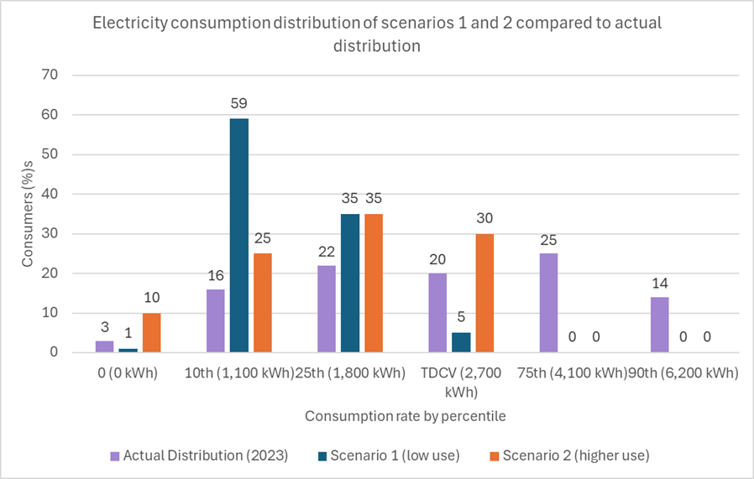

Electricity consumption distribution by percentile table
Consumption rate by percentile | 0 (0 kWh) | 10th (1,100 kWh) | 25th (1,800 kWh) | TDCV (2,700 kWh) | 75th (4,100 kWh) | 90th (6,200 kWh)
Actual Distribution (2023) | 3% | 16% | 22% | 20% | 25% | 14%
Scenario 1 (low use) | 1% | 59% | 35% | 5% | 0% | 0%
Scenario 2 (higher use) | 10% | 25% | 35% | 30% | 0% | 0%

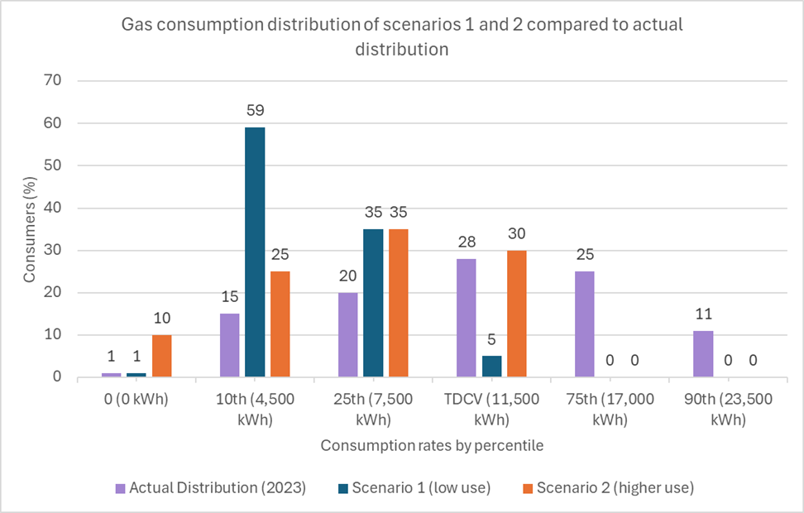
Gas consumption distribution of scenarios 1 and 2 compared to actual distribution

Gas consumption distribution by percentile table
Consumption rate by percentile | 0 (0 kWh) | 10th (4,500 kWh) | 25th (7,500 kWh) | TDCV (11,500 kWh) | 75th (17,000 kWh) | 90th (23,500 kWh)
Actual Distribution (2023) | 1% | 15% | 20% | 28% | 25% | 11%
Scenario 1 (low use) | 1% | 59% | 35% | 5% | 0% | 0%
Scenario 2 (higher use) | 10% | 25% | 35% | 30% | 0% | 0%

Tariff structures and impacts: single rate tariff
In this chapter, we set out our modelling and impacts for a single unit rate tariff structure. Under this structure, the same unit rate would apply at all levels of consumption.
As with all the zero standing charge tariff structures, the costs that would ordinarily go onto standing charges are instead added to the unit rate.
The tables and charts in this chapter show our modelling and analysis of the potential unit rates, initial under recovery, and annual consumer bills under our consumption scenarios.

Consumption scenarios and potential unit rates
These tables show our calculations for a single unit rate tariff structure under both of the gas and electricity consumption scenarios.

Electricity single unit rate table
Electricity single unit rate | Initial under recovery at TDCV (1 million consumers) | Unit rate after correction for initial under recovery | Under contribution at 1,100kWh/year per customer (10th percentile) | Over contribution at 2,700kWh/year per customer (TDCV) | Customer contribution break even point (annualised)
Scenario 1 (low use) | £106 million | 41 pence/kWh | £49 | £202 | 1,414 kWh
Scenario 2 (higher use) | £81 million | 38 pence/kWh | £80 | £128 | 1,715 kWh

Gas single unit rate table
Gas single unit rate | Initial under recovery at TDCV (1 million consumers) | Unit rate after correction for initial under recovery | Under contribution at 4,500kWh/year per customer (10th percentile) | Over contribution at 11,500kWh/year per customer (TDCV) | Customer contribution break even point
Scenario 1 (low use) | £57 million | 8.6 pence/kWh | £27 | £111 | 5,855 kWh
Scenario 2 (higher use) | £43 million | 7.8 pence/kWh | £43 | £69 | 7,200 kWh

Annual cost of energy for consumption scenarios
The scenario 1 (low use) and scenario 2 (higher use) graphs compare the annual cost of energy on the zero standing charge price cap variant to the current price cap (January to March 2025) using a single rate tariff structure for electricity and gas.

Scenario 1 (low use) - Electricity single rate tariff compared to current price cap (January to March 2025)
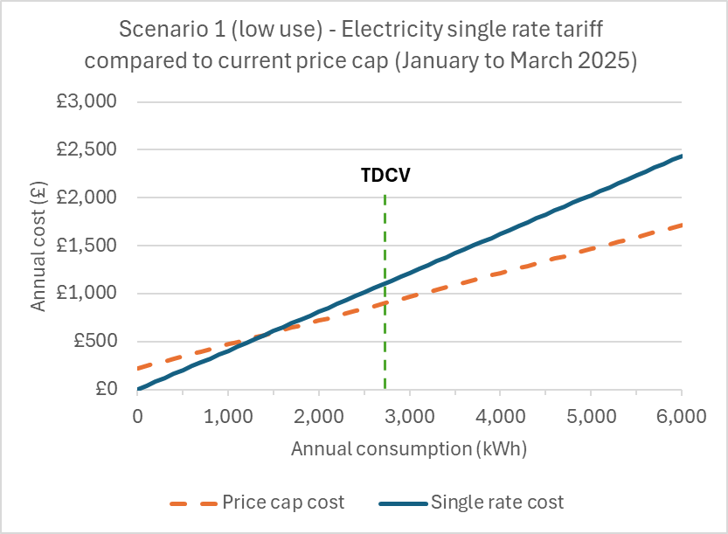

Scenario 2 (higher use) - Electricity single rate tariff compared to current price cap (January to March 2025)
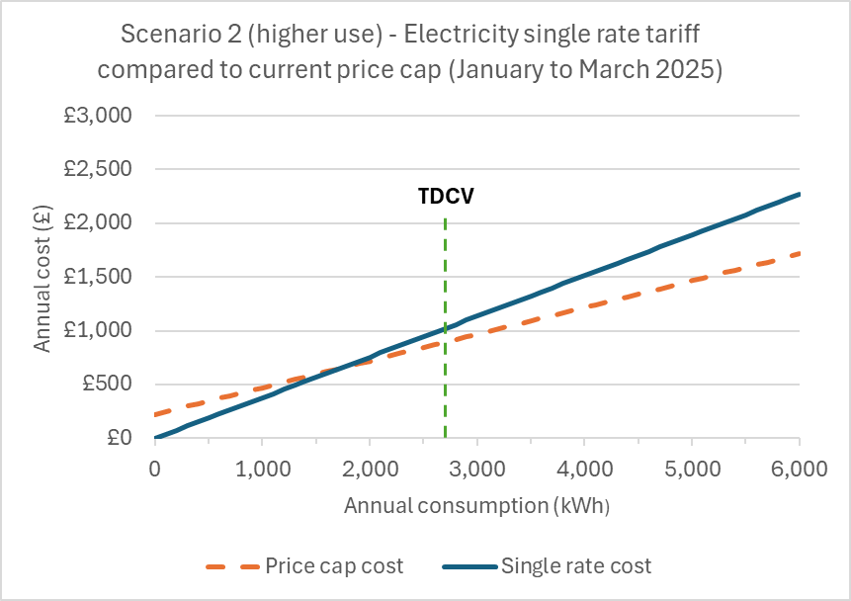
Scenario 1 (low use) - Gas single rate tariff compared to current price cap (January to March 2025)
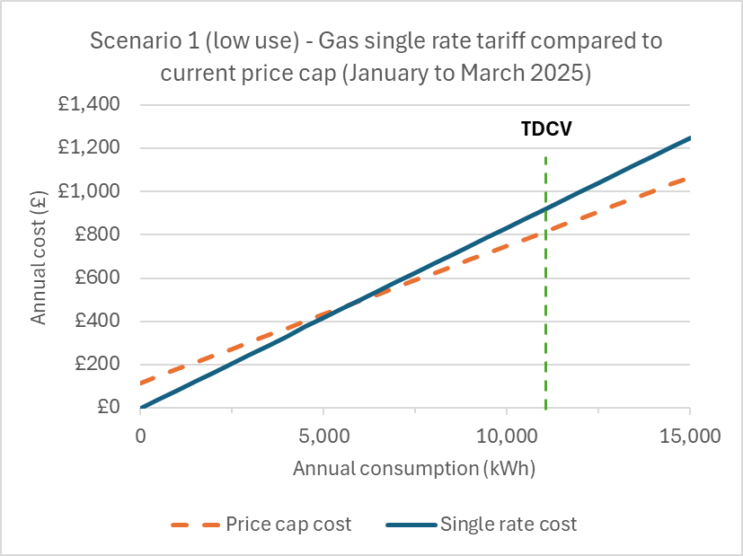

Scenario 2 (higher use) - Gas single rate tariff compared to current price cap (January to March 2025)
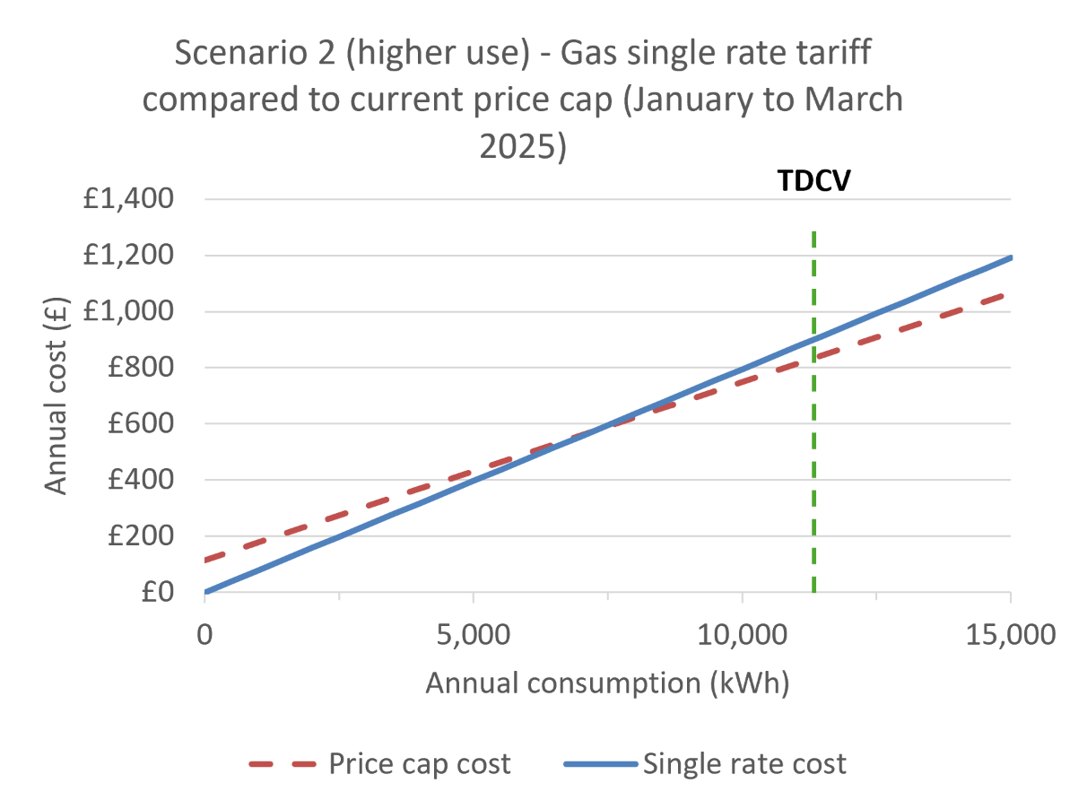
An important point to note is that without any recycling of the under recovery back onto unit rates, there is a significant revenue gap for suppliers.
Once this recycling occurs, the scenario 1 unit rate for electricity is higher than the existing price cap by around 8 pence. Scenario 2 is higher by around 5 pence. For gas, scenario 1 is higher by around 1.5 pence and scenario 2 is higher by around 1 pence.
Financially, consumers will be better off on this tariff at annual consumption rates to the left of where the lines cross, and worse off to the right.
We note that this interception point is at relatively low consumption levels: somewhere between the lowest 10 and 25 per cent of consuming households.
While we recognise that overall cost may not be the only reasons that consumers may choose this tariff (as some households may simply prefer the additional control they feel from not paying a standing charge), the additional cost that consumers would pay at typical consumption or above would be significant and would likely discourage many from choosing it.
This is a main consideration for this tariff structure, as in order for the tariff to work without leading to overall under recovery, it requires enough customers to pay more to balance out those that would pay less. On the single rate tariff, that could be a difficult balance to achieve.
Putting numbers aside, a single rate structure is a very simple tariff for consumers to understand. Arguably, it is even simpler than the existing price cap that includes both a standing charge and unit rate.
This simplicity would support consumers in comparing their expected energy bills, and help consumers in making suitable decisions for their individual circumstances and energy needs. It would also be straightforward for suppliers and other market participants like price comparison websites to implement and explain to their customers.

Tariff structures and impacts: falling block tariff
A falling block tariff means that a consumer’s first ‘block’ of consumption is priced at a higher unit rate, and once a certain amount of energy is used, the unit rate falls to a lower level.
There are a number of design considerations when looking at block tariffs, including how many blocks to use, what levels of consumption each block should comprise (the time periods associated with this consumption), and what the unit rates of each block should be. We welcome views on the design considerations we have used across each of these.
At this stage we have focused on modelling 2 blocks. It is possible to add more blocks, but doing so increases complexity for consumers without necessarily adding any significant benefit.
We have applied the standing charge costs to the first block of consumption only. This leads to significantly higher unit rates for that block.
In our examples, we chose 0 to 700kWh of annual electricity use for the first block (0 to 3,000 kWh for gas), and consumption above 700kWh (3,000 kWh for gas) for the second block.
Most households would consume to first block levels, which fits with an important design consideration that these costs should still be recovered on the whole.
For the purpose of setting out these examples we have used annual consumption for the block, but we could also consider daily, weekly, monthly or quarterly consumption instead. Later in the consultation we discuss further considerations for these time periods.
Keeping the unit rate for the second block the same as the energy price cap has advantages. It adds some simplicity for consumers in comparing tariffs. It also does not bring additional distortion to consumers’ use.
For example, if the unit rate for the second block was lower than the price cap, then higher use consumers could be financially better off on this tariff, encouraging additional use and adding further to potential under recovery. Finally, keeping the second block unit rate the same as the existing price cap means that at all levels of consumption in the second block, consumers would be paying the same differential from the existing price cap, meaning it could appeal to more customers even at higher consumption.
The tables and charts in this chapter show our modelling and analysis of the potential unit rates, initial under recovery, and annual consumer bills under our consumption scenarios.

Consumption scenarios and potential unit rates
These tables show our calculations for a falling block tariff structure under both of the gas and electricity consumption scenarios.

Electricity falling block table
Electricity falling block | Initial under recovery at TDCV (1 million consumers) | First block unit rate after correction for initial under recovery | Second block unit rate | Over contribution at 1,100kWh/year per customer (10th percentile) | Over contribution at 2,700kWh/year per customer (TDCV) | Customer contribution break even point
Scenario 1 (low use) | £2 million | 57 pence/kWh | 25 pence/kWh | £2 | £2 | 693 kWh
Scenario 2 (higher use) | £22 million | 60 pence/kWh | 25 pence/kWh | £25 | £25 | 630 kWh

Gas falling block table
Gas falling block | Initial under recovery at TDCV (1 million consumers) | First block unit rate after correction for initial under recovery | Second block unit rate | Over contribution at 4,500 kWh/year per customer (10th percentile) | Over contribution at 11,500kWh/year per customer (TDCV) | Customer contribution break even point
Scenario 1 (low use) | £1 million | 10 pence/kWh | 6 pence/kWh | £1 | £1 | 2,970 kWh
Scenario 2 (higher use) | £12 million | 11 pence/kWh | 6 pence/kWh | £13 | £13 | 2,700 kWh

Annual cost of energy for consumption scenarios
The scenario 1 (low use) and scenario 2 (higher use) graphs compare the annual cost of energy on the zero standing charge price cap variant to the current price cap (January to March 2025) using a falling block tariff structure.

Scenario 1 (low use) – Electricity falling block tariff compared to current price cap (January to March 2025)
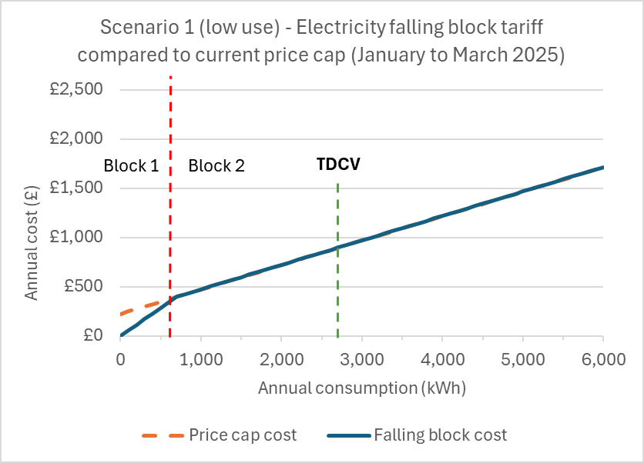

Scenario 2 (higher use) – Electricity falling block tariff compared to current price cap (January to March 2025)

Scenario 1 (low use) – Gas falling block tariff compared to current price cap (January to March 2025)

Scenario 2 (higher use) – Gas falling block tariff compared to current price cap (January to March 2025)

The falling block tariff leads to a much lower under recovery risk compared to the single rate tariff. This is because most consumers will use to the levels of the first block, and therefore will still be paying the costs of the standing charge.
Only consumers that consume less than the first block threshold will be financially better off on this tariff. At 700kWh for electricity and 3,000kWh for gas, this is only the very lowest consuming households.
In addition, the differential between the falling block tariff and the existing price cap is minimal for most consumption levels compared to the single rate tariff. This differential is also consistent for all consumption levels.
This may attract more households to this tariff, with the appeal of a zero standing charge tariff for greater control, and a smaller price difference. It therefore is likely to be easier to balance the potential under recovery.
On the other hand, because the standing charge is recovered over very low consumption levels in this example, consumers may still feel there are high initial costs. It therefore may not achieve the intention of giving consumers greater feeling of control over their bills.
We could address this by adjusting the first block threshold upwards, but doing so would then increase the amount of under recovery that would need to be made up for elsewhere.
We have tested the effect of adjusting the falling block threshold for block 1 to 1,200 kWh instead of 700 kWh using an electricity example.
It shows that the unit rate for the first block would decrease, but consumers would be continuing to pay the block 1 unit rate at higher levels of consumption. The initial under recovery would also increase under each scenario.

What happens if the first block's unit rate increases
This table shows how the scenarios would change if we increased block 1 to end at 1,200 kWh on a falling block tariff (increased from 700 kWh).

Electricity falling block increased unit rate table
Electricity falling block | Initial under recovery at TDCV (1 million consumers) | First block unit rate after correction for initial under recovery | Second block unit rate | Under/over contribution at 1,100kWh/year per customer (10th percentile) | Over contribution at 2,700kWh/year per customer (TDCV) | Customer contribution break even point
Scenario 1 (low use) | £13 million | 45 pence/kWh | 25  pence/kWh | -£6 | £14 | 1,129 kWh
Scenario 2 (higher use) | £27 million | 46 pence/kWh | 25  pence/kWh | +£9 | £31 | 1,055 kWh

Block tariffs also come with increased complexity. Consumers may find it more difficult to understand their bills or predict what their bills will be over a particular period. As a result some may also find it more difficult to compare tariffs to determine the best choice for their circumstances.

Tariff structures and impacts: rising block tariff
A rising block tariff is the opposite of a falling block, meaning that under a rising block tariff the first block of consumption is priced at a lower unit rate, and once a certain amount of energy is used, the unit rate rises to a higher level.
In our examples we have used similar design considerations as the falling block, including a 2 block structure and unit rates changing after 700kWh of electricity consumption and 3,000 kWh of gas consumption.
However, an important difference is that for the rising block, we have added the standing charges costs to the unit rate of the second block. This keeps the unit rate low for the first block.
The tables and charts in this chapter show our modelling and analysis of the potential unit rates, initial under recovery, and annual consumer bills under our consumption scenarios.

Consumption scenarios and potential unit rates
These tables show our calculations for a rising block tariff structure under both of the gas and electricity consumption scenarios.

Electricity rising block table
Electricity rising block | Initial under recovery at TDCV (1 million consumers) | First block unit rate | Second block unit rate after correction for initial under recovery | Under contribution at 1,100 kWh/year per customer (10th percentile) | Over contribution at 2,700kWh/year per customer (TDCV) | Customer contribution break even point
Scenario 1 (low use) | £142 million | 25 pence/kWh | 56 pence/kWh | £99 | £395 | 1,421 kWh
Scenario 2 (higher use) | £102 million | 25 pence/kWh | 45 pence/kWh | £141 | £188 | 1,785 kWh

Gas rising block table
Gas rising block | Initial under recovery at TDCV (1 million consumers) | First block unit rate | Second block unit rate after correction for initial under | Under contribution at 4,500kWh/year per customer (10th percentile) | Over contribution at 11,500kWh/year per customer (TDCV) | Customer contribution break even point
Scenario 1 (low use) | £76 million | 6 pence/kWh | 10 pence/kWh | £55 | £225 | 5,885 kWh
Scenario 2 (higher use) | £54 million | 6 pence/kWh | 9 pence/kWh | £77 | £103 | 7,500 kWh

Annual cost of energy for consumption scenarios
The scenario 1 (low use) and scenario 2 (higher use) graphs compare the annual cost of energy on the zero standing charge price cap variant to the current price cap (January to March 2025) using a rising block tariff structure for electricity and gas.

Scenario 1 (low use) – Electricity rising block tariff compared to current price cap (January to March 2025)

Scenario 2 (higher use) – Electricity rising block tariff compared to current price cap (January to March 2025)
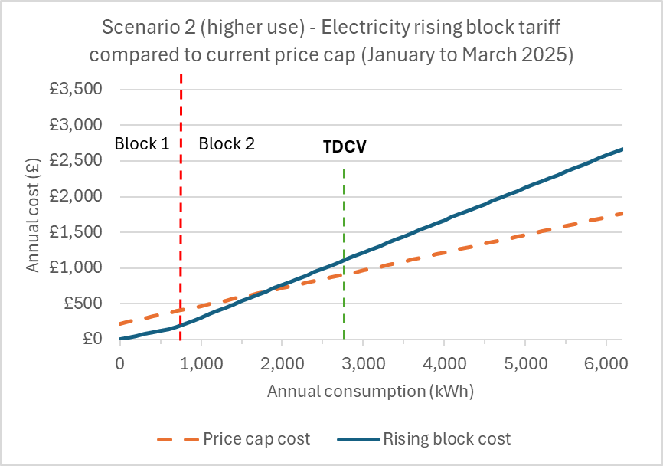

Scenario 1 (low use) – Gas rising block tariff compared to current price cap (January to March 2025)

Scenario 2 (higher use) – Gas rising block tariff compared to current price cap (January to March 2025)
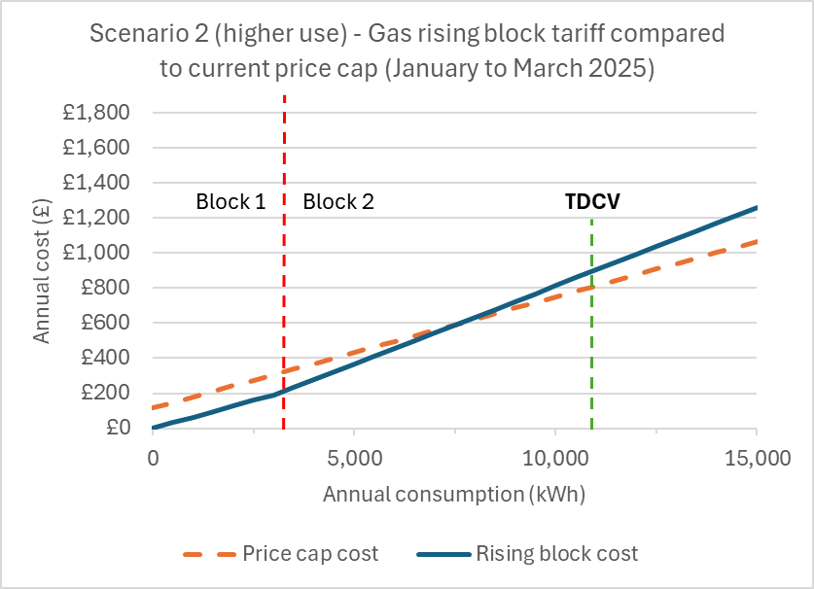
In the rising block structure, more consumers would be paying less towards the standing charge costs.
While this provides a clear benefit to those consumers, from both a financial and bill control perspective, it leads to greater under recovery risk. This is due to the rising block tariff intersecting with the existing price cap at higher levels of consumption.
In addition, because the second block of consumption rises steeply, higher use consumers are less likely to choose the tariff, which further decreases the likelihood that the under recovery will balance out.
Households that do have higher levels of consumption may be incentivised to use less, which could be beneficial for energy efficiency, but given this tariff is a choice for consumers, it is likely that consumers in this circumstance would stay with existing price cap structures rather than opt into this tariff and then become more energy efficient.
Like the falling block tariff, the threshold for the first block of consumption could increase, but doing so would make the under recovery more extreme and increase unit rates for the second block.

Tariff structures and impacts: risk and uncertainty
Across all tariff structures discussed, without a daily standing charge, consumers could benefit from a greater sense of control over their bills. This is mostly because any attempts to reduce consumption will reflect more directly on consumers’ energy bills.
For all 3 tariff structures included in our early modelling, the scenarios and assumptions used have set out to satisfy the balance of offering a worthwhile choice to consumers while suitably requiring consumers as a whole to contribute to their fixed costs.
However, as described, our analysis has been built on the basis of assumptions and scenarios, and therefore any views taken on these models in relation to how they could benefit consumers must do so with consideration that actual consumer behaviour could differ.
The significant uncertainties include (a) how many consumers will opt into the variant, and (b) what consumption those consumers will have.
If we were to roll out this variant based on a set of assumptions, and then find actual take-up and consumption is different than what we assumed, suppliers could still end up under recovering their fixed costs, which would be to the detriment of suppliers, or over recovery of costs which would be to the detriment of consumers.
There needs to be a balance where consumers on average contribute to the costs of accessing the energy system, and not simply shift these costs from one group of consumers to others.
The likelihood and magnitude of these risks arising will depend on the tariff structure chosen, and the assumed demand profile of the consumers that opt in.
One way to demonstrate this risk is to evaluate the impact of setting rates based on our high use scenario, but then actual consumption resembles our low use scenario.
If this were to happen under the single unit rate tariff for both electricity and gas, the under-recovery would be £221 million (assuming 1 million customers). For the falling block the under recovery would be £126 million, and for rising block it would be £279 million. This demonstrates the potential order of magnitude of recovery risk between each scenario.
Where considering potential under recovery of costs, we must note that suppliers have varying portfolios, and as such the risk to each supplier will likely be different.
These differences will emerge as a result of their customers’ combined annual estimated consumption, as well as the differing volumes of consumers choosing this variant.
The figures above could be scaled to demonstrate this. For example a supplier with 100,000 customers on a single unit rate tariff set using our higher consumption scenario, but with an actual consumption profile resembling our low use scenario, would face a £22.1 million under recovery risk under the single unit rate tariff.
One measure we could take to address this would be add an initial risk premium into the price cap variant. This would add increased costs to the variant to cover the risk of potential under contribution of fixed costs should our assumptions be inaccurate.
Over time, as we learned about actual consumption and contribution levels, this risk premium could be reduced. A risk premium could also be added to all price cap tariffs (including the existing ones with standing charges), but doing so would raise potential fairness concerns among those consumers that would be paying more but not benefitting from the variant.
An alternative to a risk premium would be to start the price cap variant cautiously by designing it based on the assumption of lower consumption, and then adjusting it over time to more closely match actual consumption patterns on the variant.
However, both of these measures increase the risk of over contribution by consumers.
One counter-balance could therefore be to introduce an initial true-up, so that any over-recovery is then paid back to consumers through lower rates at the next price cap setting. This would likely need to run for several periods in order to settle on an enduring level at which over or under recovery is minimal, and the true up could then be removed.
We welcome views on how to best address the risk and uncertainty around the rollout of this variant.

4. What views do you have on the various structures that we could adopt to allow consumers to contribute to fixed costs through a unit rate rather than a standing charge?
Please use this text box to explain your views.

5. Please share your feedback on the modelling we have undertaken, including what additional risks or considerations we should be taking into account, and whether there are additional or more appropriate consumption scenarios to consider.
Please use this text box to give us more details.

6. How do we best manage the risk of under recovery of fixed costs in the interest of consumers?
Please use this text box to give us more details.

7. What are your views on our assessment of the impacts and trade-offs of these options?
Please use this text box to give us more details.

Implementation approach
By introducing a zero standing charge variant under the existing energy price cap, we are looking to offer consumers a choice in how they pay for fixed costs. However, this is not intended to be a way for a group of consumers to avoid contributing to these fixed costs.
As we consider potential implementation approaches for this policy, we must continue to think about the desired outcomes of introducing a zero standing charge variant. This includes offering consumers greater choice while still providing them with protection, and also having regard to and mitigating the risk of supplier instability on consumers.
There are a number of important areas that we explore in this chapter, such as how consumers join and leave the variant, how the variant interacts with the existing price cap variants, and the implementation path for suppliers to begin to offer the variant to their customers.
In the previous chapter, we explained the risk of under recovery and how that might be addressed through tariff design. In this chapter we expand on some particular drivers of under recovery risk such as seasonal switching and vacant properties, and set out some potential approaches for addressing these risks.
We welcome feedback from stakeholders on both the considerations and the potential mitigations, as well as any other considerations we should be taking into account.

Joining the zero standing charge variant
The nature of the proposed variant means it will need a higher unit rate to be able to recover fixed costs, as discussed in previous chapters.
As a result, if a consumer who uses more energy than the breakeven point chooses a tariff under the variant, they would likely have higher bills than if they were on an existing default tariff under the energy price cap with a standing charge.
They will, however, contribute their fixed costs based on their consumption, rather than a fixed daily charge, which potentially offers a level of control that consumers are seeking.
We expect to make this variant opt-in only. This is because automatic sorting onto a zero standing charge tariff raises significant risk of error or disagreement. It would be hard for suppliers to accurately predict in all cases if a zero standing charge variant would be the cheapest for customers, as it would depend on their usage which may change in the future and varies seasonally.
In addition, since tariffs under the variant cap could, depending on the model, to have a more complex structure than tariffs with a standing charge, automatically placing consumers on this tariff without their involvement would create a risk that consumers struggle to understand how their bill has been calculated.
This may reduce trust in the energy suppliers and further reduce consumers’ confidence in engaging with their suppliers, for example to dispute bills they believe may be incorrect.
This would mean unless a consumer is on a zero standing charge fixed term tariff, it would not be the default tariff consumers are placed on when their fixed term contract ends. Instead, to join this tariff consumers would need to contact their supplier and request to be placed on a default tariff under the zero standing charge cap variant.
Suppliers currently have obligations to default tariff customers to their ‘cheapest evergreen tariff’. However, to ensure customers aren’t defaulted to a variant they haven’t chosen, we would explore the potential to a create a tariff type consideration so that the cheapest evergreen tariff offered is the one with on the variant (zero standing charge or not) the customer is on.
We acknowledge that some stakeholders have called for automatic sorting onto a zero standing charge tariff, so that consumers who do not engage with the market or their suppliers can also benefit from this variant cap.
As this is not designed to be a cost saving measure for consumers, but rather a way to offer choice in how to pay for the fixed cost element of the bill, we believe that there will not be a significant financial detriment to those who do not opt-in to the variant cap. In addition, there continue to be cheaper fixed term tariffs available for all consumers to move on to, should they wish.
This is in line with the role consumer choice has when it comes to other variables such as paying by direct debit versus standing credit. Consumers would be financially better off if they were all automatically switched to the cheapest payment method, however we believe customer choice and awareness of their payment method is more valuable than the financial benefit of automatic switching.
We are also aware of the risk of consumers with above average energy usage choosing a tariff under the variant cap despite it costing them more overall. However, we believe that making this an active choice means it is an acceptable risk that is likely to only affect a minority of consumers who value control and choice over just cost saving.
In addition, as tariffs with multiple unit rates can be harder for consumers to understand and compare between, we believe that a duty for suppliers to offer guidance to consumers on which tariff would be best for them would be an important duty, to ensure as many consumers as possible are informed of this opportunity.
If tariffs under the variant cap do have an opt-in process, at the point where customers contact their supplier to discuss moving onto the new variant, suppliers would also need to offer suitable advice based on individual consumption patterns in determining if the variant is right for them. This could fall under suppliers existing consumer duties such as the requirement to provide tariff information labels and cheapest tariff messaging.

Risks of frequent switching
We are aware that there is a possibility that consumers engage in frequent switching between the zero standing charge variant and the standard default price cap to avoid paying fixed costs.
For example, consumers might switch to the new variant in the summer when their energy use is low, and the existing variant with a standing charge in the winter when they have higher use. As a default tariff, it cannot have exit fees.
This behaviour would increase the risk of suppliers under-recovering their fixed costs and allow some consumers to avoid paying their share towards the fixed costs of the energy system.
We are considering methods we could use to mitigate this risk. One method we are considering is a lock in mechanism to prevent frequent switching. This could take the form of a minimum time limit such as one year, before a consumer is able to switch off such a tariff. This would exclude if they decide to switch to a fixed term contract, because fixed term contracts have a built in disincentive to further frequent switching with their exit fees.
Another option is to introduce a fixed cost recovery charge to tariffs under the variant cap. However, this would act like an exit fee and may conflict with the default status of the tariffs under the variant.
If we were to introduce a minimum time period, we would have to consider other considerations arising from that proposal. This includes whether we would block switching to a zero standing charge tariff with another supplier, and how we would deal with circumstances such as a change of tenancies at an address. We welcome stakeholders’ suggestions on this topic.
Although we are concerned about frequent switching, we also recognise that a concern is that consumers will make their choice based on their current energy needs, which may change at short notice if there is a change in circumstances. Therefore, limits on switching may make these consumers worse off.

Vacant properties
If this cap variant is introduced, the unit rates would be designed so that most consumers still contribute their share of fixed costs. However, vacant properties or second homes that are only occupied for short parts of the year could avoid fixed costs entirely. This would exacerbate under-recovery risk to the market, and add to the amount that needs to be added to unit rates for all other consumers on the variant.
To avoid this risk and keep vacant properties from inflating the costs of the variant, we could require a minimum consumption level in order to qualify for the zero standing charge variant. This could be set at a level that most households where someone lives year-round would qualify. We need to establish whether the minimum would be calculated daily, monthly, or quarterly.
Given some of the example households most likely to benefit from this variant could be prepayment consumers not using gas in the summer, or people who are away from home for longer periods of time, a longer assessment period may be better to ensure they are eligible.
Potentially, a minimum level of consumption could be explained to consumers in innovative ways. For example, it could be described as ‘for £X per year, you get y kWh of energy, and after that you pay Z pence per kWh.’
While this risks closely resembling a standing charge, it may help consumers understand how their bill works and what they get for different levels of payment across a period of time.
By setting the minimum consumption requirement at very low levels that it only affects vacant or mostly vacant properties, most consumers would be indifferent to the minimum requirement as it wouldn’t affect them.

Calculating the variant
The energy price cap is calculated every 3 months. As we consider the potential for a ‘lock-in’ period by which consumers are not able to move away from this variant, this opens the question as to how frequently this variant should be calculated.
We think the simplest option for consumers is to update this variant alongside the existing energy price cap. This ensures that consumers and suppliers both face up to date pricing and have no gain or detriment compared to the existing price cap.
The variant would be calculated using the same inputs as the existing price cap. Given the additional complexity of calculating another energy price cap variant we may need an extra 1 to 2 days to calculate the zero standing charge variant (depending on the complexity of any new mechanism introduced).
We would therefore expect to announce the existing cap update and any zero or low standing charge variant 1 to 2 days later than we currently do, following the completion of the relevant wholesale observation window.
This would reduce the notice period suppliers’ and other stakeholders have by 1 to 2 days. We think the impact of this small notice period reduction should be manageable for suppliers and consumers, but we welcome views on this point.

Calculating consumption blocks
If we took forward a block tariff, we would also need to decide what time period the consumption blocks would be calculated on.
We could adopt a daily, weekly, or quarterly approach to calculating the block. This would mean that the usage level at which different price blocks start would be calculated to correspond to typical consumption across that time period.
For example, if we calculated on an annual basis, the first 700kWh used that year would be charged at the first unit rate, whereas if we calculated on a daily basis, it would be around 2kWh each day would be charged at the first rate.
We do not think calculating the variant on an annual basis is compatible with quarterly energy price cap updates.
The energy price cap requirements are determined by ‘charge restriction periods’ that have effect for less than a year. So having a variant where customers would pay an inflated unit rate for the first block of consumption that year would not see the benefit of the reduced unit rate before the next charge restriction period ‘resets’ the energy price cap. Due to this issue, we are not moving forward with the idea of calculating the variant on an annual basis.
If we were to calculate this variant on a daily, monthly or quarterly basis that would increase the complexity of both the price cap modelling and supplier billing required. This variant would also likely require substantial changes to the supply licence conditions and the energy price cap calculation formulae.
There would also be an impact on a consumer’s contribution to fixed costs. With a relatively low consumption threshold for the first block, a longer period gives less ability to avoid costs, as there will be ups and downs.
A more granular approach would lead to less cost recovery as where could be days where demand was very low, such as summer days or periods where a property is temporarily vacant, like for holidays.
Therefore, we need to consider the most suitable period for calculating any variant of the energy price cap.

Prepayment levelisation
We also need to consider the effect that the proposed variant would have on the existing levelisation between prepayment and direct debit payment methods.
In April 2024, we introduced levelising standing charges between prepayment meter and direct debit payment, supported by a standing charge reconciliation mechanism. The details of this can be read in our levelisation decision.
This mechanism aims to levelise the standing charges costs between between prepayment and Direct Debit payment types. Previously, prepayment meter customers had higher standing charges than customers using other payment methods.
In deciding how the proposed new variant is calculated, we have the choice of whether the variant would continue to levelise these costs between payment types.
We consider that levelising or not are both viable options without significant disruption to the existing reconciliation mechanism or price cap calculations. However, each may require small changes to processes, which may add time and resource. For example, levelising the variant would have some impact on our modelling processes and timeframes each price cap period.
Levelisation already applies to all customers, both under the price cap and on fixed term tariffs. Our decision to introduce payment method levelisation was based on improving outcomes for prepayment customers, who are more likely to be in vulnerable situations.
Therefore, we currently consider that the case for levelisation of these costs would extend to consumers on the zero standing charge price cap variant as well. We welcome feedback on the impact of levelisation on the variant.

Smart meter eligibility
Implementing block tariffs on traditional meters is complex, as suppliers rely on accurate, regular consumption data in order to bill appropriately for each block of consumption. This is particularly the case for more granular blocks of consumption such as daily.
If we are implementing a block tariff solution, we may want to consider whether households must have a smart meter to qualify.
While this would simplify implementation of a block tariff structure and decrease risks and costs to suppliers, it would limit its benefits to those consumers that do not have smart meters.
If non-smart meter householders were included, there would also be an increased risk of complex rebilling being required after meter readings have been submitted.
Limiting the cap variant to smart meters only could serve as an additional incentive for households to request a smart meter. However, it could also seem unfair to consumers that aren’t able to get a smart meter for reasons beyond their control (for example, signal issues or lack of space for a smart meter), therefore limiting access to the cap variant.

Multi-rate meter eligibility
We also need to consider how the zero standing charge variant may interact with multi-rate meters, such as Economy 7 meters, particularly under block tariffs.
If multi-rate meters are included in this variant, it would create complex interactions between the peak and off-peak rates that customers pay at different times of the day, and the changes in unit rates due to a block tariff structure.
For those with electric heating, different block sizes may be needed in recognition that consumption is likely higher.
This would result in tariffs that are hard for suppliers to implement. They would also be very difficult for consumers to understand and use effectively.
We are keen to hear your views on whether we include or exclude multi-rate tariffs in the eligibility criteria for this variant due to the difficulties it would pose.
We also note that Economy 7 customers typically have higher demand, so they are unlikely to want to switch to this variant. However, some may argue that they still want to have the option available to them.

Targeted eligibility
Some stakeholders have argued that standing charges are a particular issue for people with a prepayment meter. This is because standing charges can build-up over the summer months or other periods of non-use and can create a significant barrier to reconnection for these consumers.
Zero standing charges also fit more naturally with a prepayment method, in that you pay for what you use when you use it. Therefore the potential advantages of a zero standing charge tariff are stronger for prepayment meter consumers as there is a unique case for change compared to other payment types.
We are seeking views on whether the zero standing charge variant should apply only to prepayment meter customers, as they are the most adversely affected group of consumers. This would also have the benefit of reducing market risk as suppliers’ exposure to under-recovery would be reduced in scale.
On the other hand, it may also risk creating market distortions as it means any under-recovery would impact prepayment meter specialist suppliers significantly more than those with fewer prepayment meter customers. We note that the suppliers already offering zero standing charge products under the existing price cap are prepayment specialist suppliers.
If we created a zero standing charge variant only for people with a prepayment meter, then direct debit and standard credit customers that wanted to access the variant would only be able to do so by moving to a smart prepayment tariff. Alternatively, they could access a zero or lower standing charge tariff through the fixed market.
We could also consider targeting this variant towards those who are most affected by standing charges with other mechanisms.
For example, being a recipient of the Warm Home Discount could be an eligibility criteria. This would also have the benefit of reducing market risk by reducing the scale of exposure to under recovery. However, it could mean that suppliers with significantly more Warm Home Discount customers than others are disproportionately affected. It would also exclude others that might benefit from a zero standing charge tariff.
We would welcome your feedback on what eligibility criteria you think would be most appropriate.

Impact on supplier processes
We acknowledge that there would be steps suppliers need to take to put this new variant into place for consumers. This is likely to include changes to billing practices, metering arrangements, customer information and engagement, as well as changes to staff training needs.
Alongside existing responsibilities, there is the potential for additional obligations to be placed on suppliers. These would focus on supporting consumers in making suitable choices for themselves when determining the suitability of this variant for their circumstances.
These additional obligations will need to be outlined, most likely in the supplier licence conditions. This is likely to include mandating suppliers offer tariffs for this price cap variant, changes to the cheapest tariff messaging, and changes to the cheapest evergreen tariff process.

Trialling or phasing the introduction
Given the risks and uncertainties raised within this consultation, we could consider running a trial before introducing the tariff market-wide. For example, we could work with two or three suppliers to offer a zero standing charge tariff to a limited number of consumers.
Doing so would enable us to better understand likely demand for the tariff, and what potential consumption profile consumers on the tariff might have. This would help us set and adjust the rates to minimise under recovery risk and to better adapt for consumer needs and preferences.
Another option could be to phase the implementation of the variant, for example starting with smart prepayment meters only, before widening it to other meter and payment types.
Each of these options would add to the implementation time required before market-wide roll out. We welcome views from stakeholders on whether these options would be desirable, and how we might design a trial or phased introduction.

8. Please share your feedback on the potential criteria and process for joining and leaving the zero standing charge price cap variant.
Please use this text box to give us more details.

9. Considering our assessment of the challenges and opportunities around non-smart meters, prepayment meters and multi-rate meters, what could be done in these areas to support the success of a zero standing charge price cap variant?
Please use this text box to give us more details.

10. Do you have any views on how suppliers could offer block tariffs to consumers without smart meters?
Yes / No
Please delete only one item.
If you chose 'Yes’, please use this text box to explain your views.

11. What support should be in place for consumers in deciding if the variant is the right tariff for them?
Please use this text box to give us more details.

12. Are there any considerations we should make in relation to supplier implementation and ongoing delivery of this price cap variant?
Yes / No
Please delete only one item.
If you chose ‘Yes’, please use this text box to provide your feedback.

13. Please share your views on trialling or phasing implementation, and how this might work effectively.
Please use this text box to give us more details.

Attach a supporting document
In addition to answering our questions, you can also attach a PDF (pdf), Word (doc) or Excel (xls) file to the consultation. This will be published as part of your response.
Please make sure you remove any confidential information before uploading your file.

14. Upload your file
Please attach a copy of any documents you wish to include to this printout.
Make sure your document is either a PDF (pdf), Word (doc) or Excel (xls) before uploading.

About you

15. What is your name?
Name (Required)

16. What is your email address?
Email (Required)

17. Are you responding as an individual or on behalf of an organisation?
(Required)
- Individual
- Organisation
Please delete only one item.

18. If you're responding on behalf of an organisation, please tell us the name of the organisation.
Organisation (Required)

19. If responding on behalf of an organisation, please tell us what type of organisation you represent. If you are responding as an individual you can leave this blank.
(Required)
Please delete all items that aren’t relevant.
- Charity
- Environmental group
- Energy supplier
- Energy network operator
- Government
- Local authority
- Local community
- Trade association
- University
- Other (please specify)
If you answered ‘other’, please use this text box to tell us which organisation you represent.

20. Tell us which sector you work in.
Please delete only one item
- Electricity and gas
- Electricity only
- Gas only
- Other (please specify)
If you answered 'other', please use this text box to tell us which sector you work in.

21. Do any of your responses contain confidential information?
Yes / No
Please delete only one item.
If any of your responses contain confidential information, please use this text box to clearly explain which parts of your response you wish to be kept confidential. We will publish your name as part of the response unless you tell us not to.
How your response will be published
We will publish non-confidential responses, but we will not publish responses from individuals.
If the information you give in your response contains personal data under UK General Data Protection Regulation (UK GDPR) we will be the data controller for the purposes of UK GDPR. We use the information in responses to perform our statutory functions. Read details about confidentiality and our legal duties in the Ofgem consultation policy and Ofgem privacy policy.
You can ask us to keep your response, or parts of your response, confidential. We will respect this, subject to obligations to disclose information such as under the Freedom of Information Act 2000, the Environmental Information Regulations 2004, statutory directions, court orders, government regulations or where you give us explicit permission to disclose. If you do want us to keep your response confidential, we will get in touch with you to discuss which parts of the information in your response should be kept confidential, and which can be published. We might ask for reasons why.
If you wish to respond confidentially, we will keep your response confidential, but we will publish the number (but not the names) of confidential responses we receive. We will not link responses to respondents if we publish a summary of responses, and we will evaluate each response on its own merits without undermining your right to confidentiality.

Feedback
We want to make our consultations and calls for input better.
Please help us improve our consultations and calls for input by answering the questions below. Your answers will not be published.

22. How easy was the information to understand?
Please delete only one item.
- Very easy
- Easy
- Hard
- Very hard
Please use this text box to tell about any other comments you may have.

23. How easy was it using this platform (Citizen Space)?
Please delete only one item.
- Very easy
- Easy
- Hard
- Very hard
Please use this text box to tell about any other comments you may have.

